Summary of Today's Agenda

Storage Pools
Create storage pools on test servers (default 250 GB). Additional storage can be expanded using NAS devices, potentially scaling from a few terabytes to hundreds of terabytes. CPU and RAM remain unchanged. Follow a strict naming convention.

Storage Volumes
Activate the storage pool before use. Create storage volumes using QCOW2 format for Linux virtual machines and RAW format for Windows. After creating pools and volumes, virtual machines can be deployed.

Virtual Machine Setup
CentOS Stream 9 was used as the example Linux operating system.

VM Installation and Networking
Configure CPU settings, install the virtual machine, and then configure networking options such as bridge or direct attachment modes.

Operating System Installation
During installation, avoid selecting the GNOME desktop environment if a lightweight server installation is preferred. Assign meaningful hostnames. IP addresses may be generated automatically.

Network Configuration
Review and configure IPv4 settings, gateway information, and DNS servers as required.

Steps:

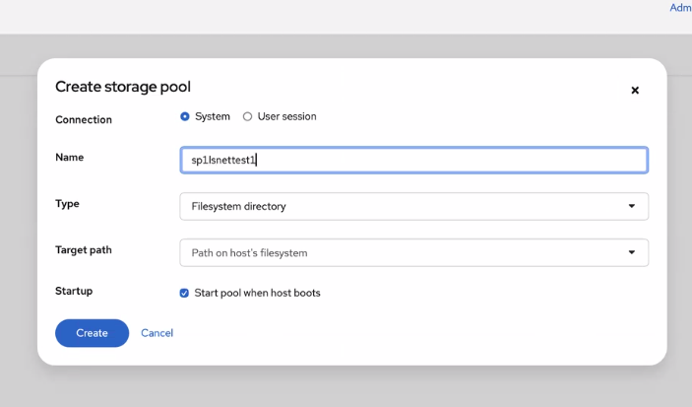

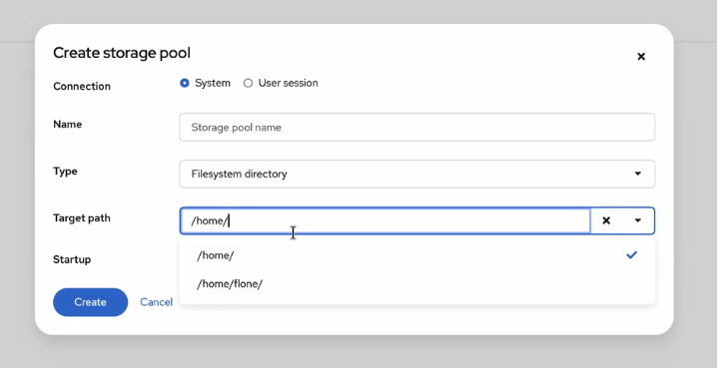

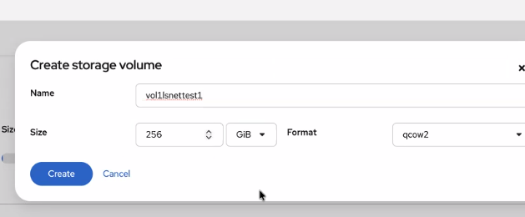

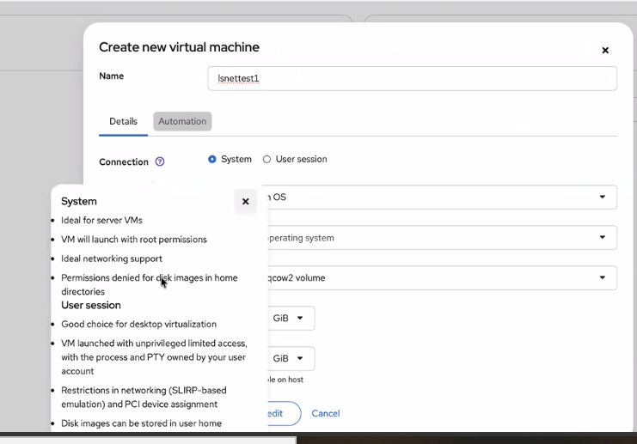

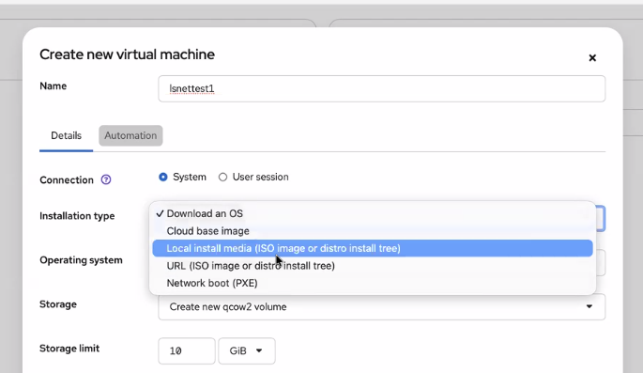

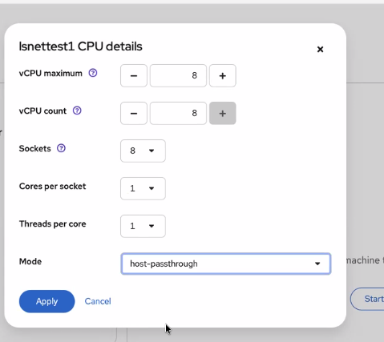

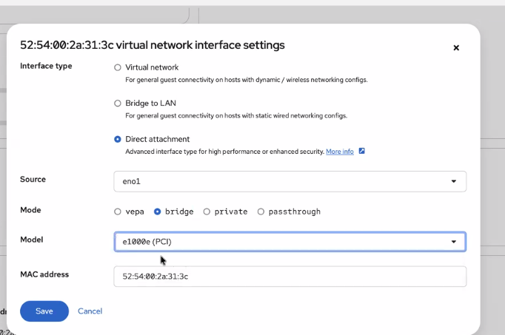

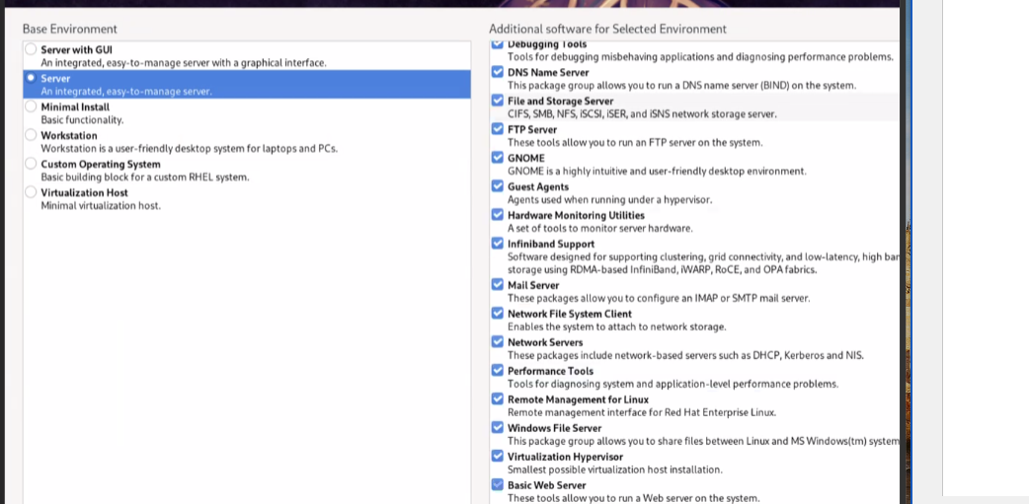

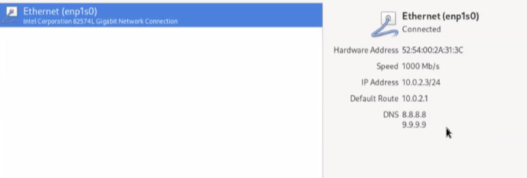

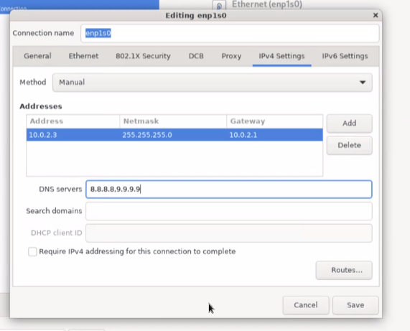

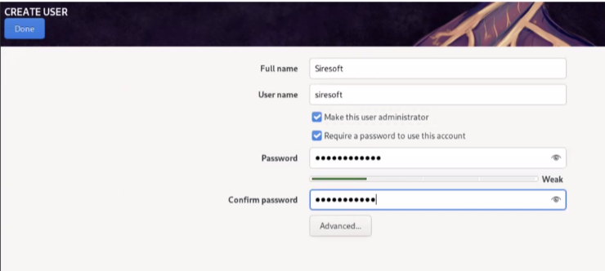

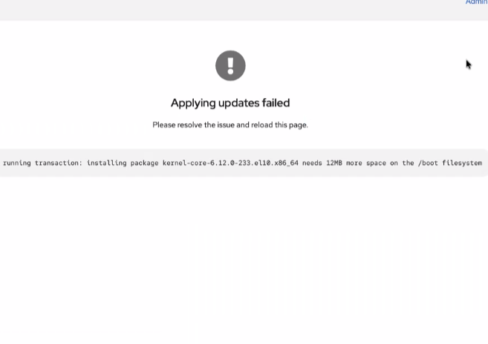
Command to remove old kernels:
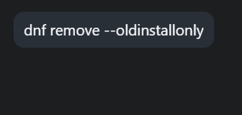
Interworx installation link https://appendix.interworx.com/current/getting_started/setup_information/install-interworx-control-panel.html

